I chose the first project in the list, which asked for the results of a given metabolic equivalent formula on the details provided. The method for finding the desired result (assuming I did it correctly) seemed simple, and I worked through a few Java tutorial videos to get started.

I knew that ultimately I had to just plug in my example athlete’s data – 150lbs, ran & played ball for 30mins, slept for 6 hours – into the formula. I started by creating variables for each characteristic of this sample athlete, the weight, run time \* METS value, ball time \* METS value, sleep time \* METS value. I knew I could combine the activities into activitySum, and another variable to convert the weight into kg in weightInKg. The formula was applied in the METS variable. I started both of these as a ‘float’ but was corrected by the IDE to change to ‘double’. I think I could have cast the variables to truncate or round to keep the values smaller, but I left well-enough alone.

I look forward to making a nicer program that takes user input and prints out results more ‘conversationally’, but I’m not getting ahead of myself. Program finishes with exit code 0 and the result is 1073.8636

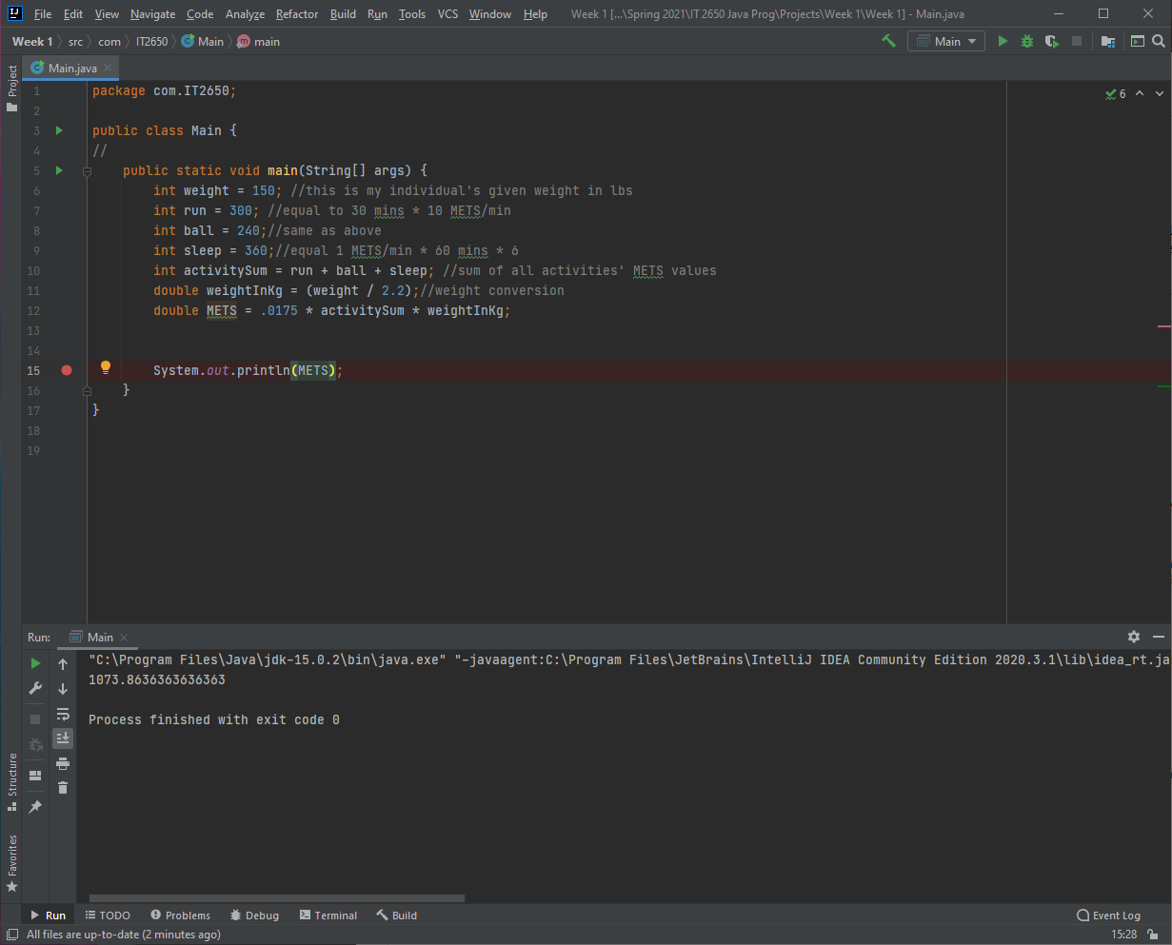

Using the debug feature in IntelliJ, I was able to get this screenshot where the debugger shows the values at each line.

